Article Summary

Yuki Watanabe

Price

[Cost +Profit]

〇Comparison between the strategy of Xbox one and Play Station 4 (PS4)

> Total BOM cost (Bill of Materials) of Xbox One is higher than that of PS4

> Manufacturing cost of Xbox One is higher than that of PS4

　> Profit margin of Xbox One is higher than that of PS4

|  |  |  |
| --- | --- | --- |
|  | Xbox One | Play Station 4 |
| Total BOM Cost | $ 457.00 | $ 372.00 |
| Manufacturing Cost | $ 14.00 | $ 9.00 |
| BOM+Manufacturing | $ 471.00 | $ 381.00 |
| Profit Margin | $ 28.00 | $ 18.00 |
| Retail Pricing | $ 499.00 | $ 399.00 |

(IT media news, 2013)

→The total cost of Xbox One is higher than that of PS4. Why?

↓**The reasons** ↓

[Value Added]

1. The cost of SoC (system on a chip, integrated circuit) is $110.

> The most expensive materials among them used in Xbox One.

> The cost of SoC in PS4 is $100.

2. Kinect, a motion capture technology, is $75.

> Kinect is able to make our own body into “a controller”

> It is a factor causing the difference between these game devices in cost.

(Nihon Keizai Shinbun, 2013)

[Competition Based]

〇The idea of competition based seems not to be true of the case of Xbox One.

> Because it seems that its company are concerned about not reasonal price but its high quality and unique characters instead of its high cost.

> Even if Xbox one does not sell very much at first, its beneficial game titles can compensate for the loss. (Steve Mather, 2013)

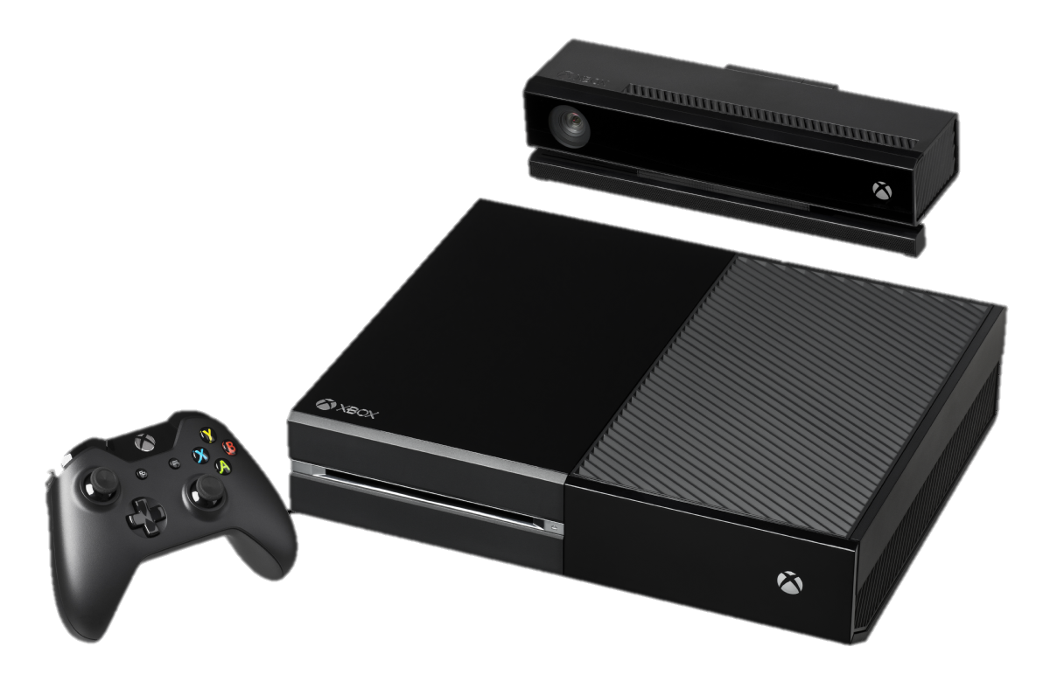

[Reference]

> IT media news. (2013). 「Xbox One」の製造原価はPS4より90ドル高い──IHS iSuppli調べ*.*[online] Available at [http://www.itmedia.co.jp/news/ articles/1311/27/news042.html](http://www.itmedia.co.jp/news/%20articles/1311/27/news042.html) [Accessed 17 May 2018]

> Nihon Keizai Shinbun. (2013). *新型「Ｘｂｏｘ」、価格と原価の差は28ドル ＩＨＳ調査.* [online] Available at [https://www.nikkei.com/article/DGXNAS FK2800Q_Y3A121C1000000/](https://www.nikkei.com/article/DGXNAS%20FK2800Q_Y3A121C1000000/) [Accessed at 17 May 2018]